Recognized pattern: Vidro_variety1

The pattern identified has the following forms:

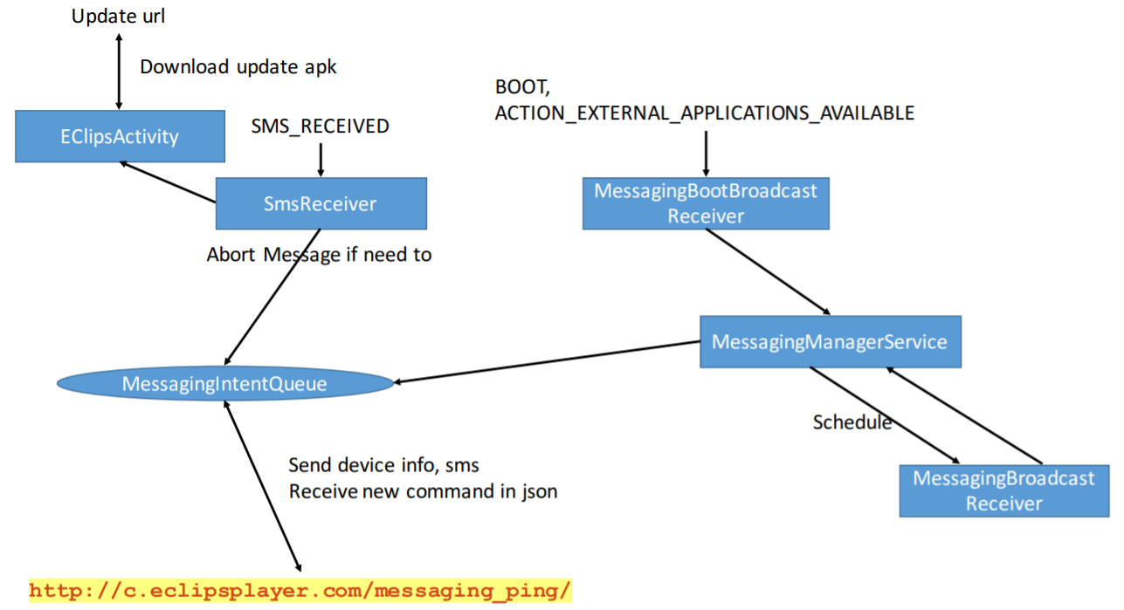

Sample app has a name: EClips

Name of this app: Navit

For functional modules (access to personal information):

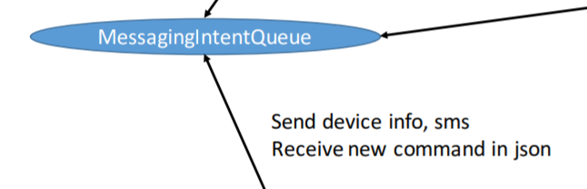

Corresponding to the key code in sample app:

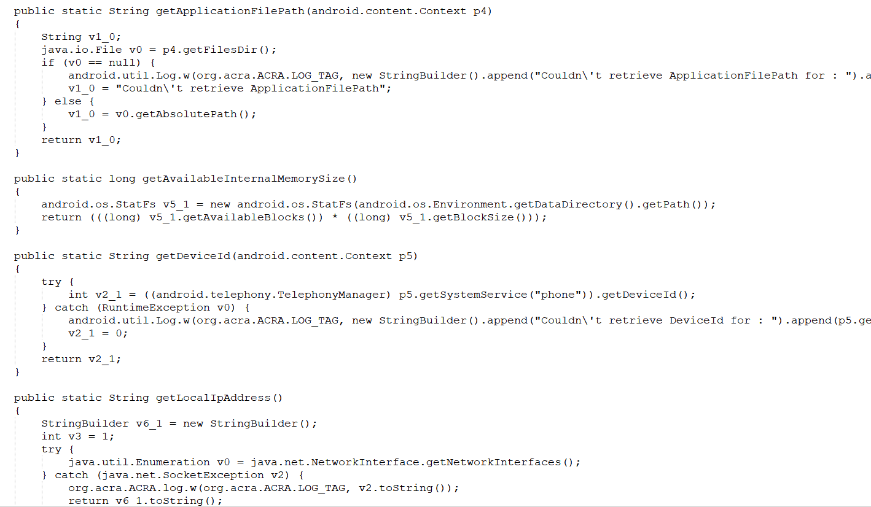

Corresponding to the key code in this app:

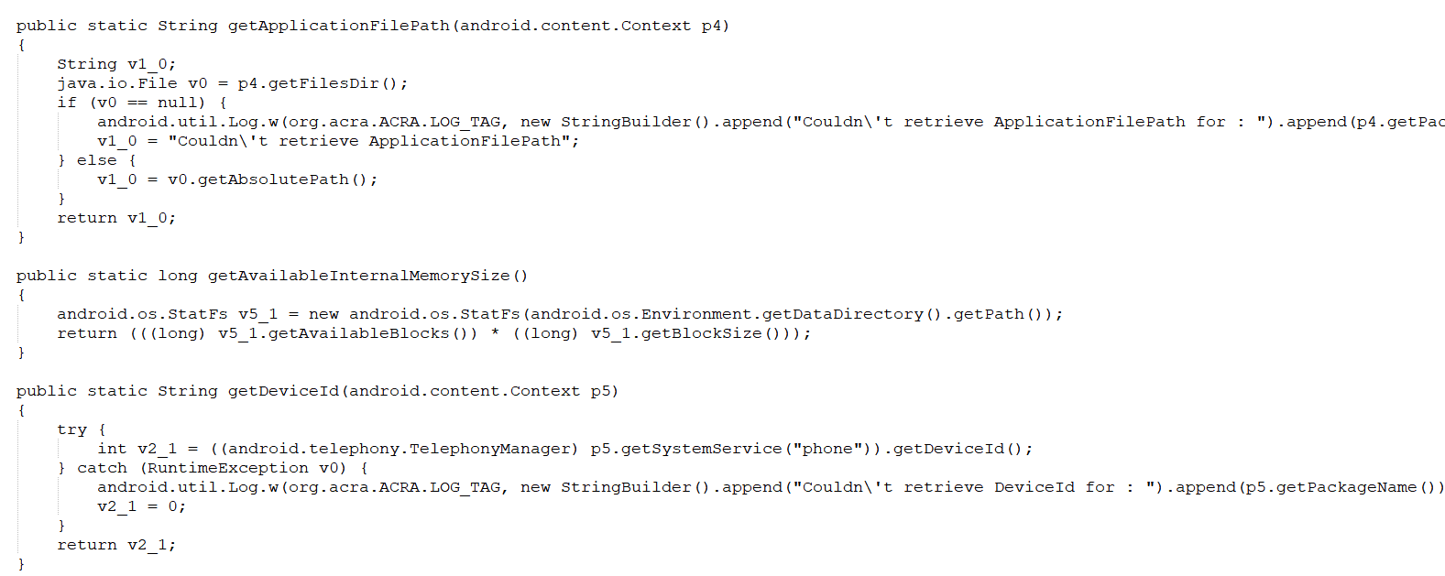

For functional modules:

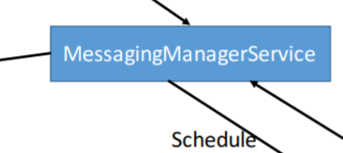

Corresponding to the key code in sample app:

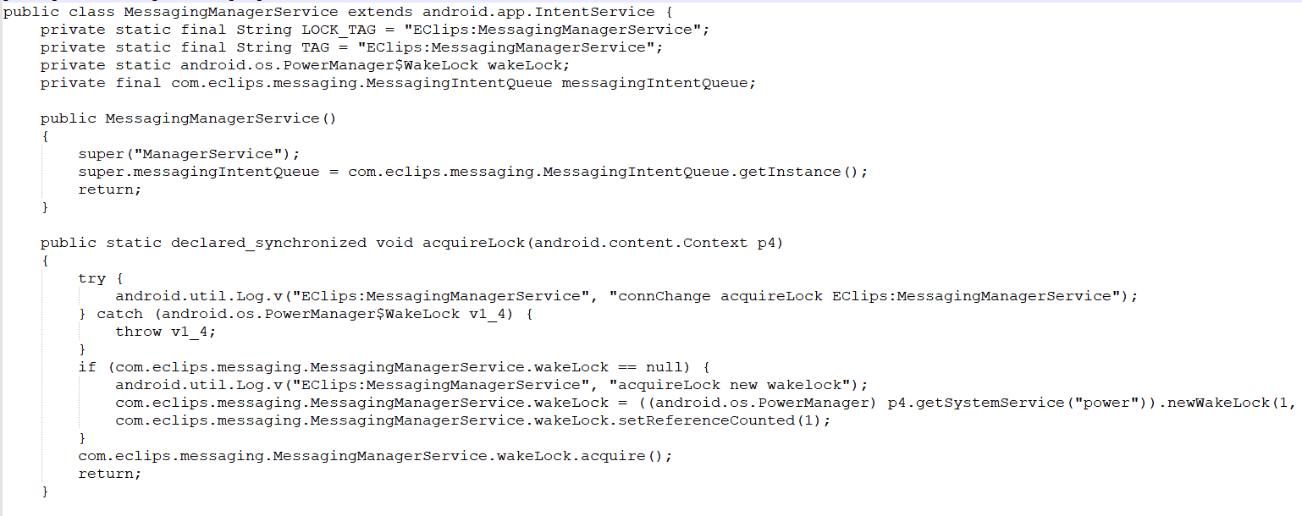

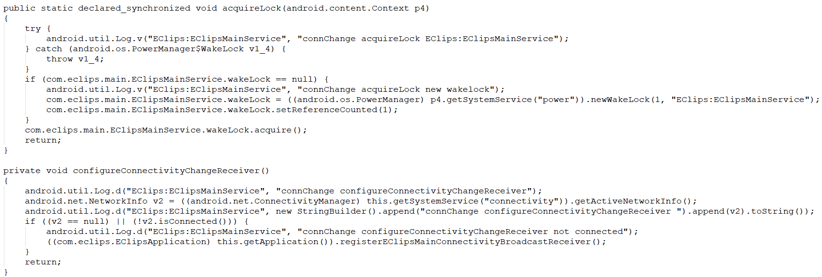

Corresponding to the key code in this app：

